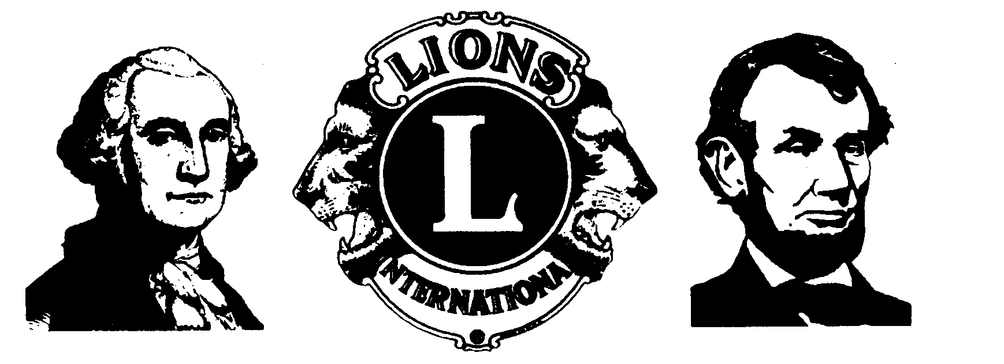
January 1, 2014

SUBJECT: 2014 BLAND MUSIC CONTEST

The Annandale Lions Club is pleased to announce its annual BLAND MEMORIAL MUSIC COMPETITION, to take place on Saturday Afternoon, February 22, 2014, starting at 2:00 p.m.. This years’ competition will be held at the United Baptist Church of Annandale, (formerly known as the First Baptist Church ). The address is 7100 Columbia Pike, where John Marr crosses Columbia Pike and becomes known as Chatelain Road. Burger King is directly across the street. I will individually contact each contestant with more detailed contest operation information, as they send me their applications.

This year, instead of mailing out registration forms and letters, I am using the Internet and its facilities. I plan to place hard copies of the application, this letter, and the Contest Rules at the George Mason Library in Annandale. This is to accommodate anyone who is not able to print from the web site www.annandalelions.org.

First and second place prizes will be awarded to winners in both Vocal and Instrumental categories. Every contestant will be given an attractive, framing-quality certificate of participation. The two finalists in our contest will advance to the Regional Runoff to be held in March, and winners there will advance to the District 24-A Bland Contest in April. District finalists go on to the Lions of Virginia State Finals in May, to compete for scholarship money at a number of levels, as described on the registration form.

Applications must be received by me via e-mail or regular USPS mail not later than Saturday February 15.

We hope Music Teachers will encourage one or more of their students to apply to a Bland Music contest-ours, or that sponsored by any Club in Lions District 24-A. We feel the Annandale Contest provides an excellent opportunity for a young musician to perform before an appreciative and supportive audience of 60 to 75 Lions, guests, parents, music teachers, neighbors, and friends of music. They gain valuable competition experience, and receive pointers from our four adjudicators.

Contest procedure will be simple. As applicants arrive, they will sign in for position on the contest itinerary in the sanctuary foyer. They will then locate their pair of judging forms, attach one to each music score, and submit those to a club member wearing a badge “Bland Greeter”. Contestants may wear whatever apparel they feel comfortable. As each contestant goes forward to perform, he/she will be asked to introduce himself/herself, the composition title, his/her accompanist (if appropriate), and the composer. Feel free to add any further information about the composition that would interest the audience. Families and friends of contestants are invited to attend, as are music teachers, choral and band directors, or anyone in the role of music advisor.

Here is a link to a flyer suitable for posting.

Should additional information be required, I can often be reached at 703-941-3631, or a message may be left for my response. Applications may be sent at any time via the mail or email.

Lion Gene Boucher, Contest Chairman
4024 Travis Parkway
Annandale, VA 22003
mgboucher@cox.net

